GRAPH THEORY ASSIGNMENT
Network Analysis of a Synthetic Scale-Free Graph

Name: Divesh Jadhwani
PRN: 25039001007
Subject: Graph Theory
Submission Date: May 10, 2026

Executive Summary
This assignment constructs and analyzes a synthetic complex network using the Barabási-Albert preferential attachment model [1]. A graph of 8,192 nodes and 24,567 edges was generated, exhibiting scale-free and small-world properties characteristic of real-world networks such as social graphs, citation networks, and the World Wide Web.

Key Findings
- Scale-free degree distribution confirmed (power-law): few hub nodes with very high degree [1].
- Small-world property: Network diameter of only 7 hops across 8,192 nodes.
- 24 distinct communities detected by the Louvain algorithm (modularity Q = 0.386) [2].
- Hub nodes serve as critical connectors for rapid information spread across the network.
- NetworkX [3] and Gephi [8] analyses produce consistent, complementary results.

Part I: Network Generation

1.1 Barabási-Albert Model
The Barabási-Albert (BA) model generates scale-free networks through preferential attachment: new nodes are added one at a time, and each connects preferentially to nodes that already have high degree ("rich get richer"). This mechanism produces a power-law degree distribution P(k) ~ k^(−γ), which matches many real-world networks including the internet, social media platforms, and biological interaction networks [1].

1.2 Implementation Parameters
- Model: Barabási-Albert preferential attachment (nx.barabasi_albert_graph) [1, 7]
- Number of nodes (n): 8,192
- Edges per new node (m): 3
- Total edges generated: 24,567
- Random seed: 42 (for reproducibility)
- Graph type: Undirected, connected
- Export format: GEXF → GT_Assign_25039001007.gexf

1.3 Graph Export
The generated graph was exported to GEXF (Graph Exchange XML Format), a standard format supported by Gephi [8] and other graph tools. The file GT_Assign_25039001007.gexf was then imported into Gephi for further interactive analysis in Part III.

Part II: NetworkX Analysis and Visualization

2.1 Network Visualizations
Five layout algorithms were applied using NetworkX [3, 7] to visualize the network structure from different perspectives. An additional community-detection visualization is also included.

2.1a Spring Layout — Node Color by Degree
Force-directed layout using the Fruchterman-Reingold algorithm [5]. Node color encodes degree (red = high-degree hub nodes, yellow = low-degree peripheral nodes). Hub nodes naturally gravitate toward the center due to their many edge connections.
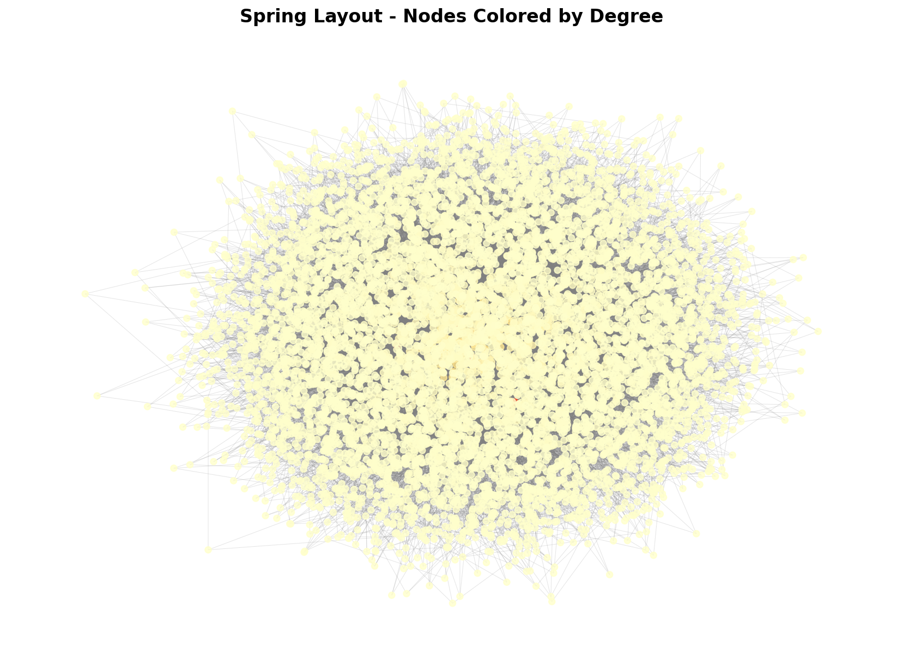
Figure: 2.1a Spring Layout — Node Color by Degree
2.1b Circular Layout — Node Color by Betweenness Centrality
All nodes are arranged equidistantly on a circle. Node color represents betweenness centrality — brighter nodes act as bridges on shortest paths between other node pairs, making them disproportionately important for network communication.
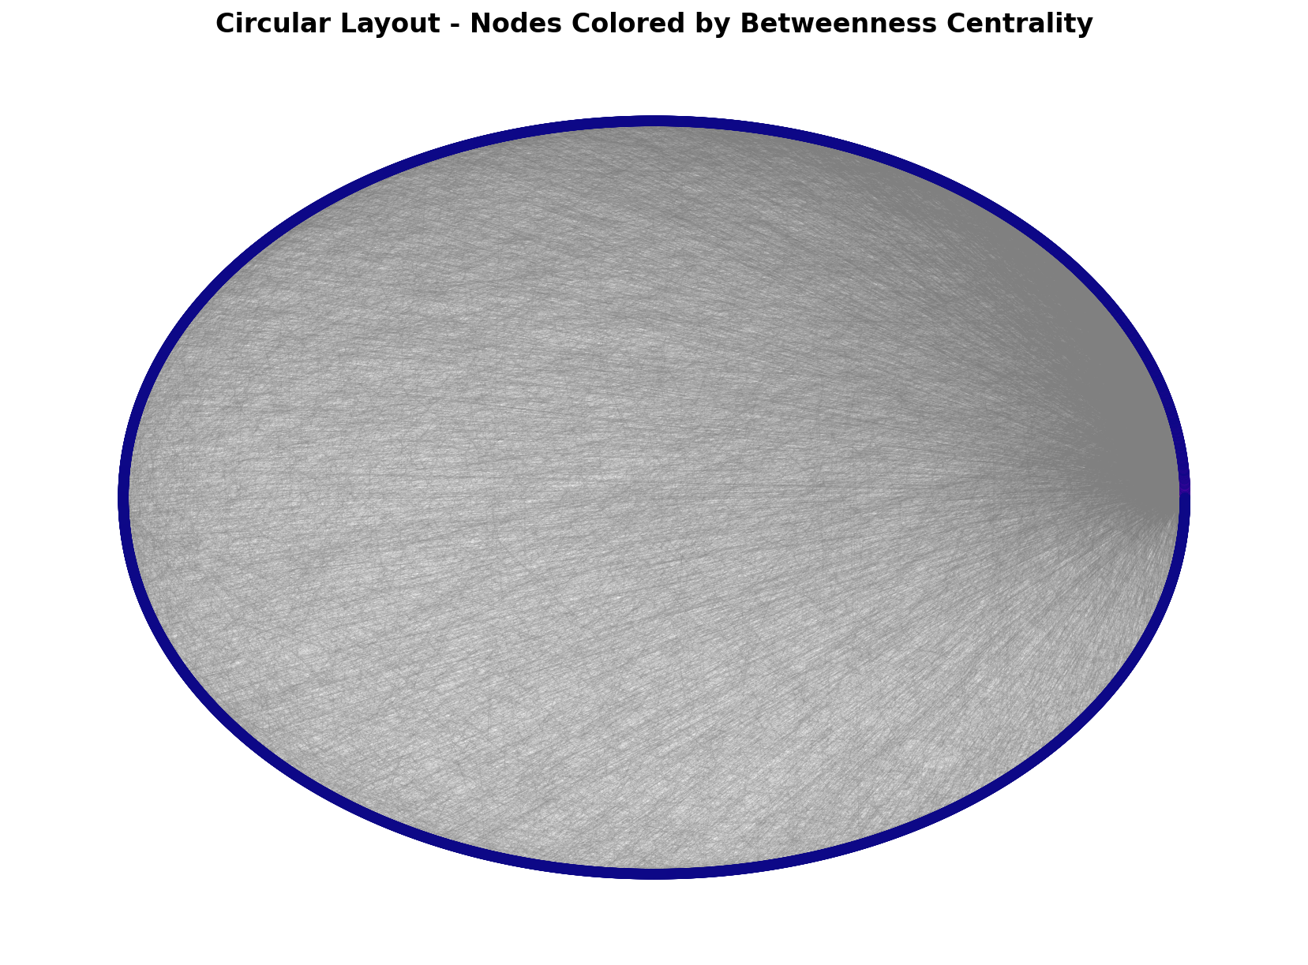
Figure: 2.1b Circular Layout — Node Color by Betweenness Centrality

2.1c Kamada-Kawai Layout (2,000-node sample)
A high-quality spring-electrical model that minimises graph-theoretic distances. Sampled to 2,000 nodes for computational feasibility. Reveals cluster structure more clearly than random layouts; structurally similar nodes appear spatially close.
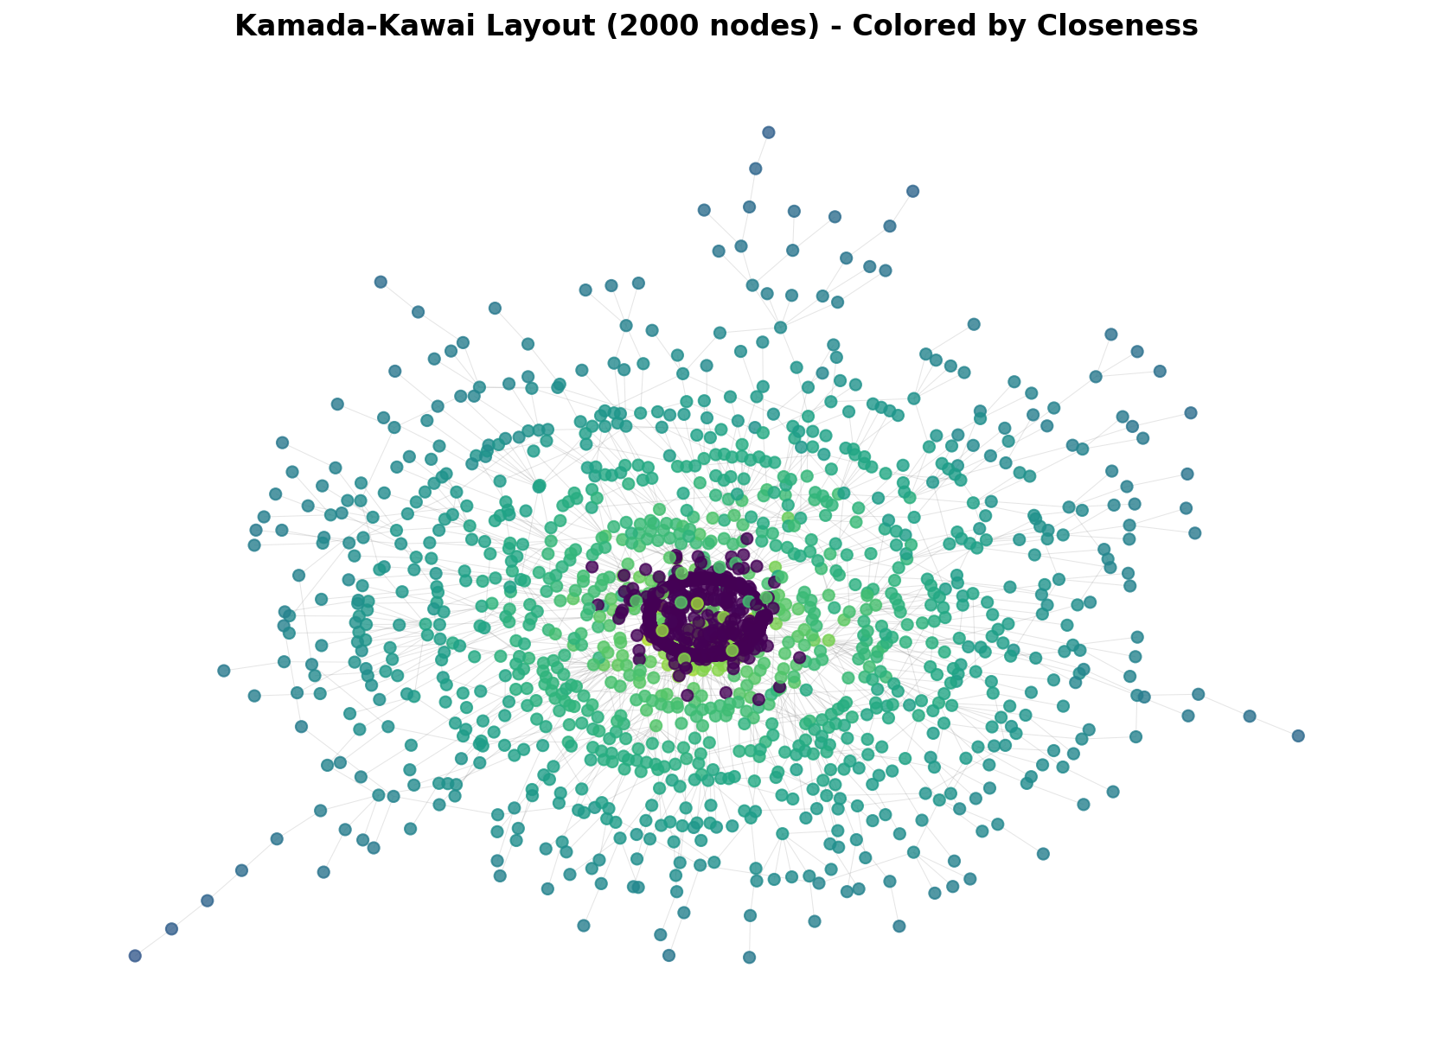
Figure: 2.1c Kamada-Kawai Layout (2,000-node sample)

2.1d Shell Layout — Hierarchical by Degree
Nodes are arranged in concentric rings based on degree. The innermost ring contains the highest-degree hub nodes; peripheral low-degree nodes occupy the outer rings. This layout emphasises the hierarchical structure of scale-free networks [1].
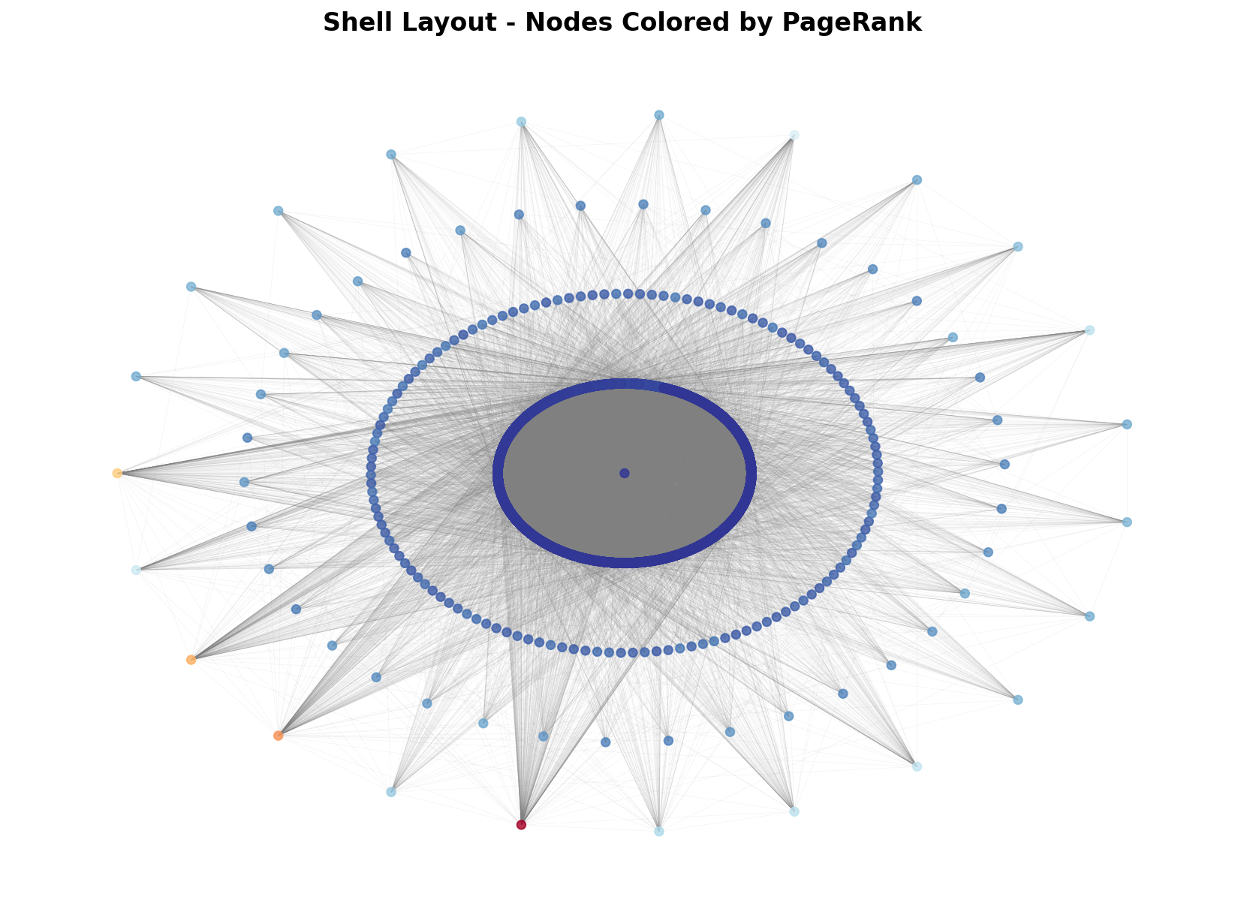
Figure: 2.1d Shell Layout — Hierarchical by Degree

2.1e Spectral Layout — Eigenvector-Based Positioning
Node positions are computed from eigenvectors of the graph Laplacian matrix. Nodes that are structurally similar (same community) cluster together in this embedding, making latent community structure visible without explicit community detection.
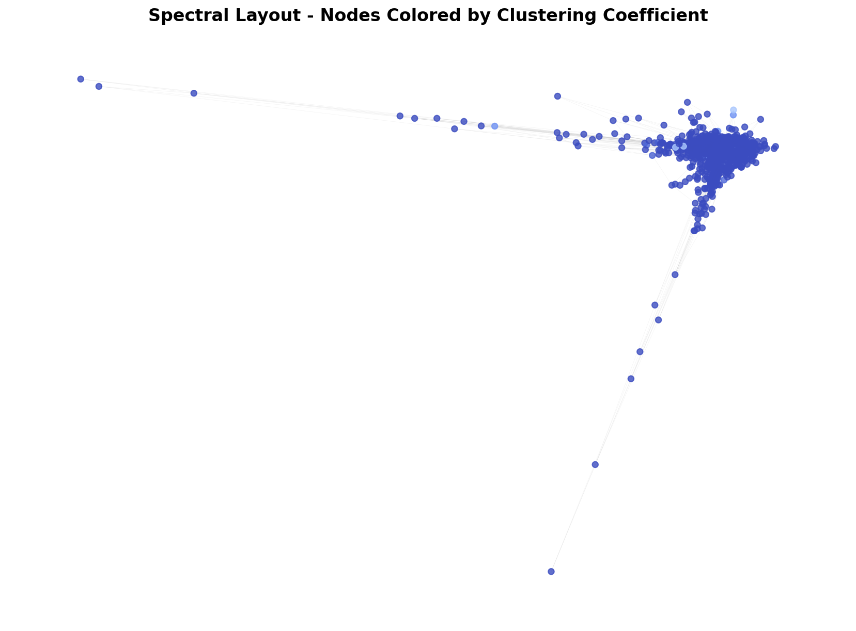
Figure: 2.1e Spectral Layout — Eigenvector-Based Positioning

2.1f Community Detection — Louvain Algorithm
24 distinct communities detected using Louvain modularity-maximisation [2] (modularity Q = 0.386). Each color represents a different community; hub nodes appear larger to indicate their higher degree. Communities correspond to densely interconnected subgroups within the network.
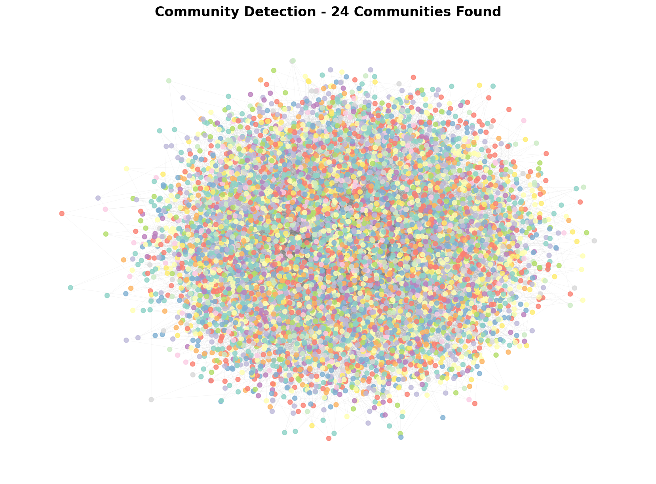
Figure: 2.1f Community Detection — Louvain Algorithm

2.2 Degree Distribution Analysis
The degree distribution reveals the scale-free nature of the network. The left panel shows the linear-scale histogram; the right panel shows the same data on a log-log scale. The approximately straight line on the log-log plot confirms a power-law distribution — a hallmark of Barabási-Albert networks [1].
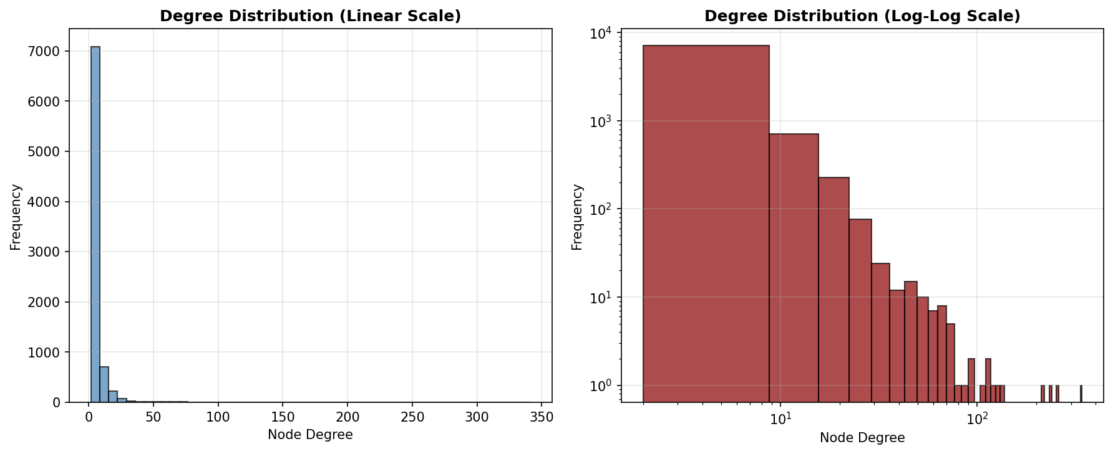
Figure: Degree Distribution (Linear Scale and Log-Log Scale)

2.3 Clustering Coefficient Analysis
The left panel shows the distribution of clustering coefficients across all nodes. Most nodes have low clustering (typical of scale-free networks [1]), while a few highly interconnected nodes form local cliques. The right scatter plot (degree vs. clustering) shows the inverse relationship: hub nodes have lower clustering coefficients because their many neighbours are unlikely to be mutually connected.
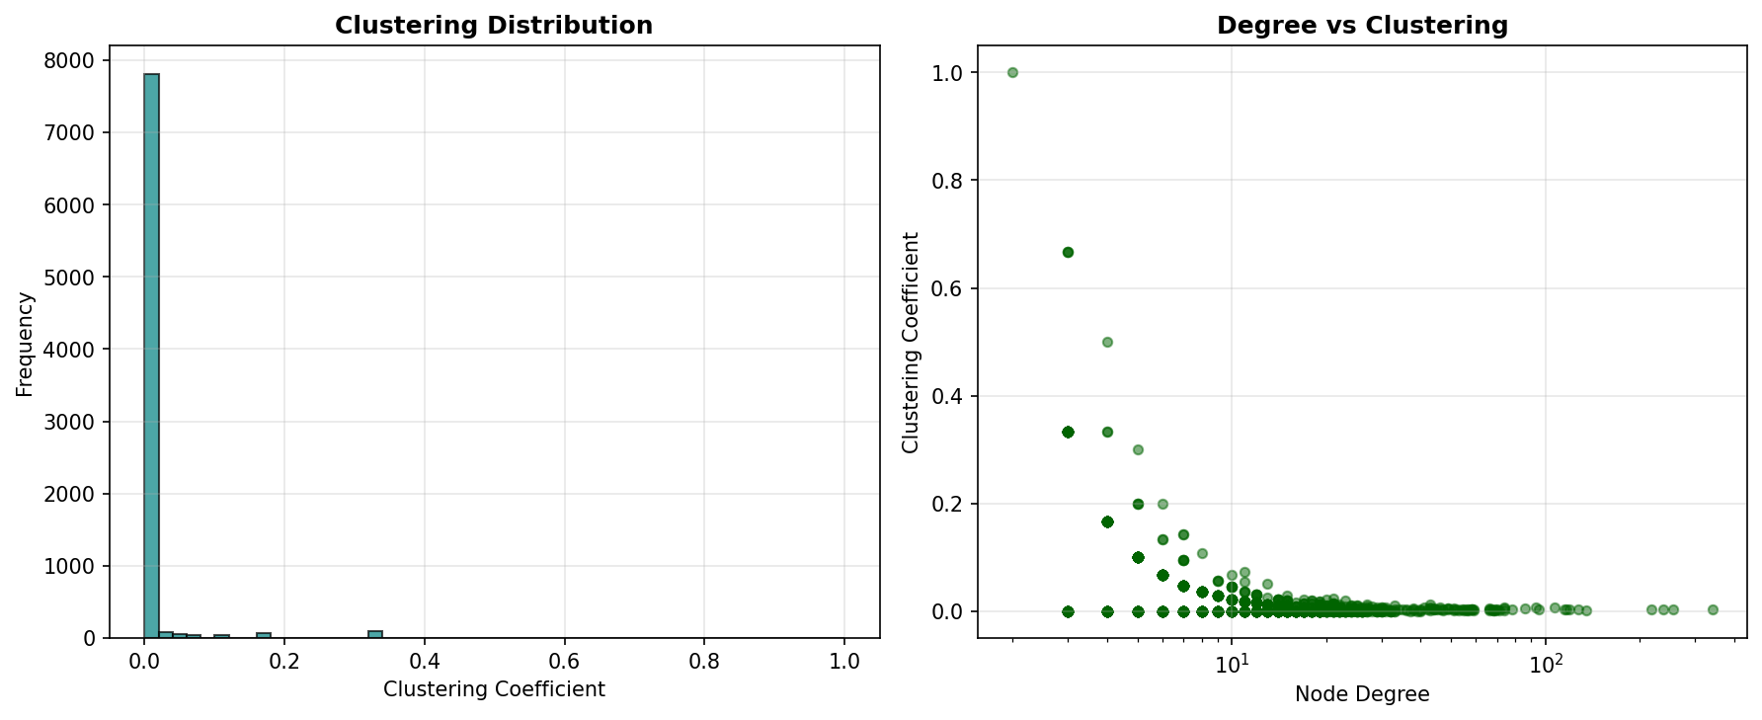
Figure: Clustering Coefficient Distribution and Degree vs. Clustering

2.4 Network Metrics Summary
The table below presents all computed network metrics for the generated graph:

Metric | Value
Number of Nodes | 8,192
Number of Edges | 24,567
Network Density | 0.000732
Average Degree | 5.9978
Network Diameter | 7
Network Radius | 4
Average Clustering Coefficient | 0.007183
Mean Closeness Centrality | 0.240251
Mean Betweenness Centrality | 0.000390
Number of Communities (Louvain) | 24
Modularity Score | 0.386147

2.5 Metric Interpretations
Diameter (7): The maximum shortest path length is only 7, meaning any two nodes can communicate within 7 hops. This small-world property is a defining feature of real-world complex networks and enables rapid information dissemination.
Radius (4): The eccentricity of the most central node is 4 — at least one node can reach every other node in just 4 steps, confirming strong connectivity at the network core.
Average Degree (5.9978): Each node connects to approximately 6 others on average. This matches the BA model [1] parameter m = 3 (expected average degree ≈ 2m = 6), confirming correct generation.
Network Density (0.000732): A density of 0.073% means the network is very sparse — only a tiny fraction of all possible edges exist. This is typical of large real-world networks.
Average Clustering Coefficient (0.007183): Low clustering is characteristic of scale-free networks [1]: hub nodes have many neighbours but those neighbours are unlikely to be connected to each other.
Mean Closeness Centrality (0.240251): Closeness measures how quickly a node can reach all others. A mean of 0.24 indicates moderately efficient global communication, driven primarily by hub nodes.
Mean Betweenness Centrality (0.000390): The low mean value indicates that a small number of bridge nodes carry disproportionately high traffic across shortest paths.
Communities (24), Modularity Q (0.386): 24 distinct communities were detected using the Louvain algorithm [2]. A modularity score of 0.386 indicates moderate-to-strong community structure — communities are meaningfully denser internally than expected by chance in a random graph.
Part III: Gephi Analysis and Visualization
The GEXF file was imported into Gephi [8] desktop for interactive visual analysis. Three layout algorithms were applied, nodes were coloured by community and sized by degree, and five network statistics were computed independently within Gephi.
3.1 Initial Network Import
After importing GT_Assign_25039001007.gexf, the graph appears as a dense blob before any layout is applied — the raw, unpositioned representation of all 8,192 nodes and 24,567 edges.
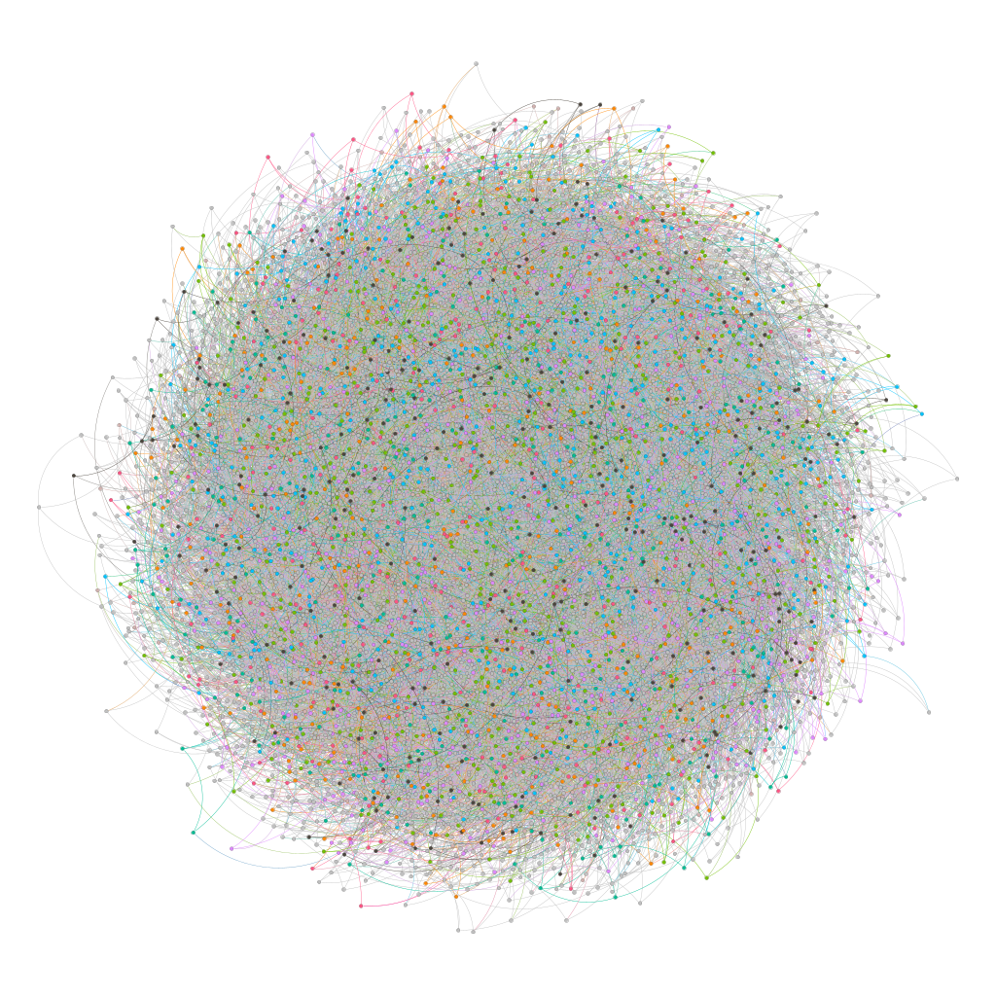
Figure: Initial Graph View in Gephi (before layout)
3.2 ForceAtlas2 Layout
ForceAtlas2 [4] is Gephi's primary force-directed layout. It simulates repulsion between all nodes and attraction along edges, running for 60–90 seconds. Nodes naturally organise into clusters corresponding to communities, with hub nodes forming the structural backbone between clusters.
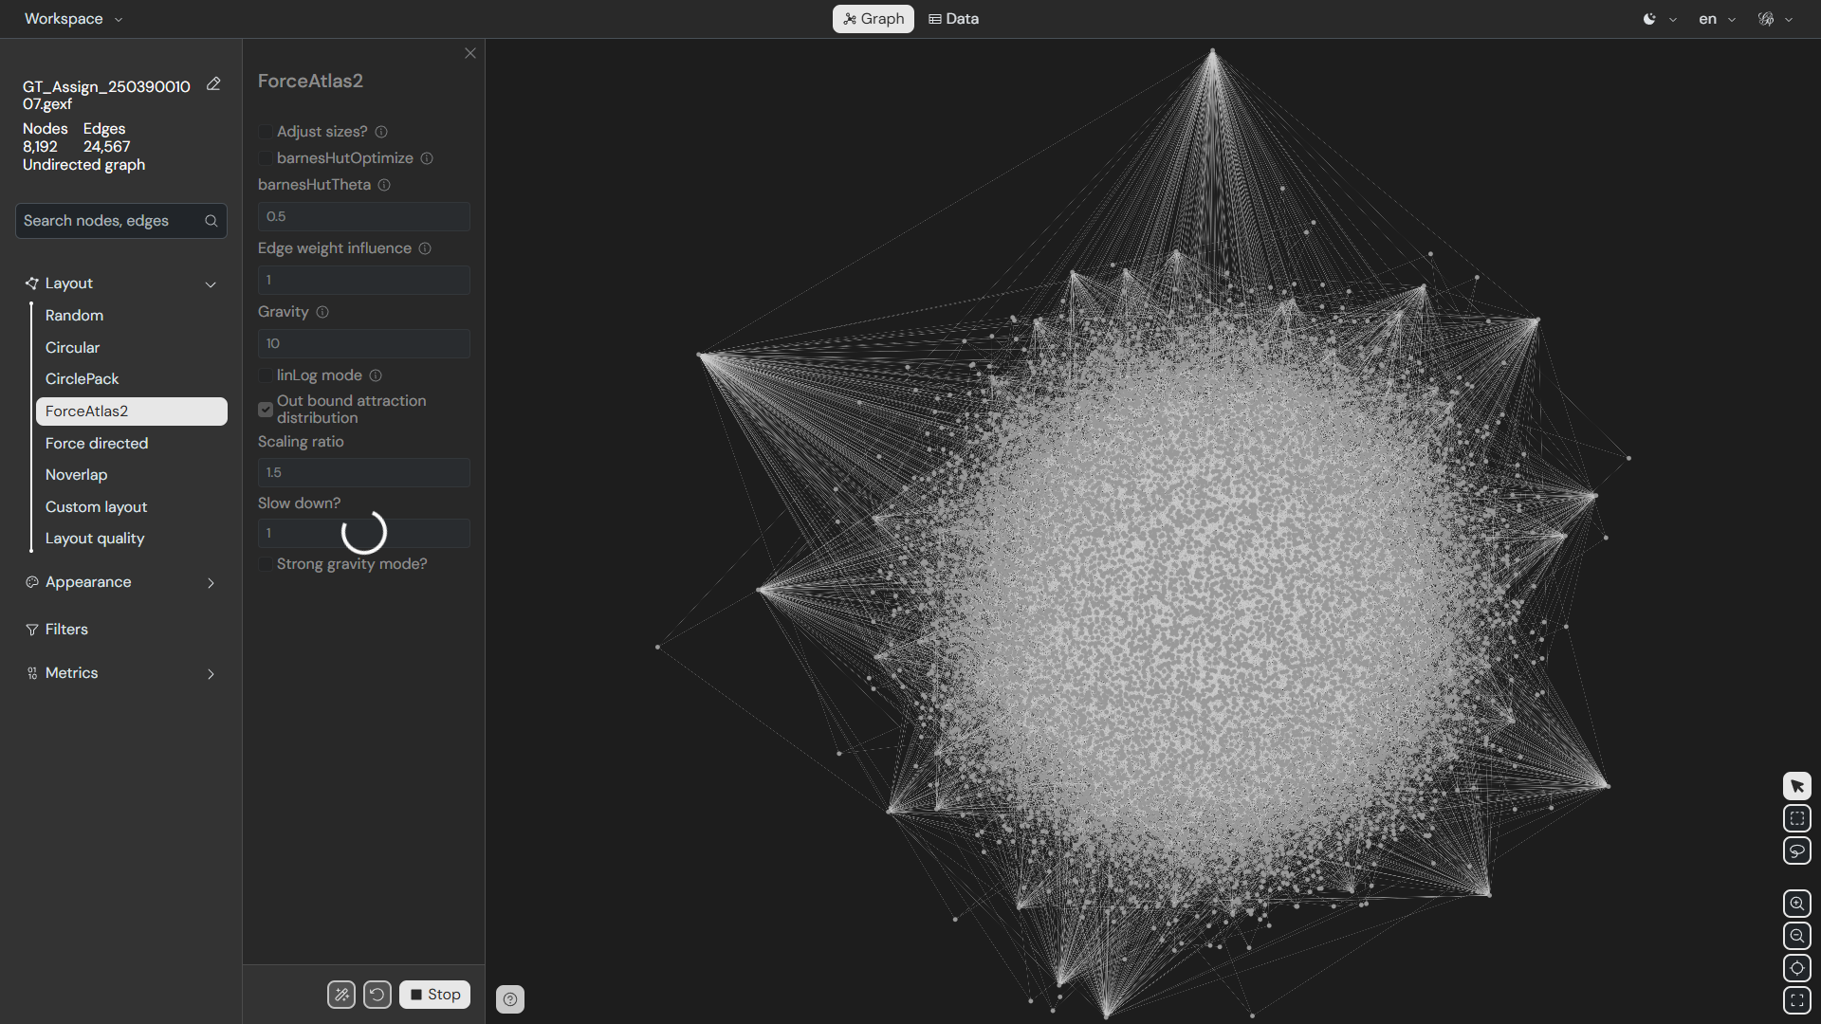
Figure: ForceAtlas2 Layout (Gephi)

3.3 Fruchterman-Reingold Layout
The classic Fruchterman-Reingold algorithm [5] treats edges as springs and nodes as charged particles. It distributes nodes more uniformly than ForceAtlas2. Community clusters are visible but with less distinct separation.
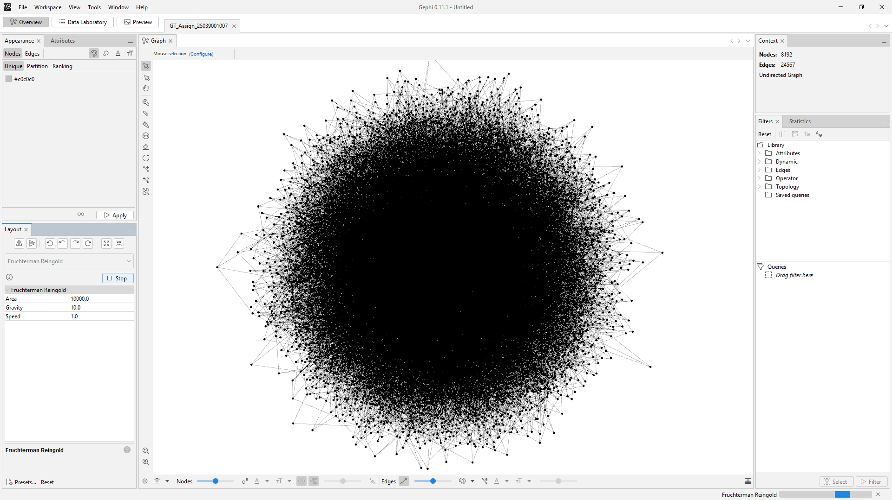
Figure: Fruchterman-Reingold Layout (Gephi)
3.4 Yifan Hu Layout
The Yifan Hu multi-level algorithm [6] is optimised for large graphs. It uses a hierarchical approach — coarse layout first, then refinement — running faster than ForceAtlas2 while producing clear community separation.
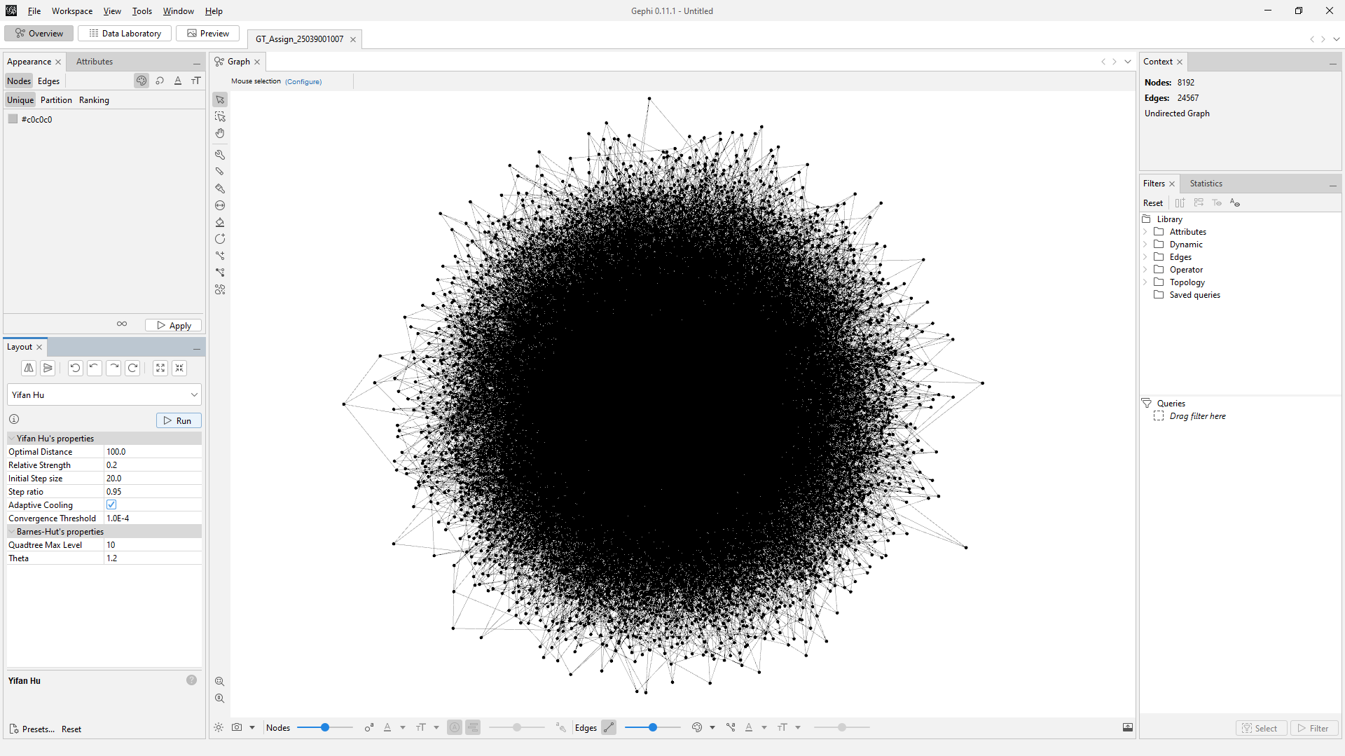
Figure: Yifan Hu Layout (Gephi)
3.5 Nodes Coloured by Community, Sized by Degree
After running the Modularity statistic in Gephi [8], nodes were coloured by Modularity Class (each community gets a distinct colour) and sized by Degree (larger nodes = higher-degree hub nodes). This visualisation simultaneously reveals community structure and individual node importance.
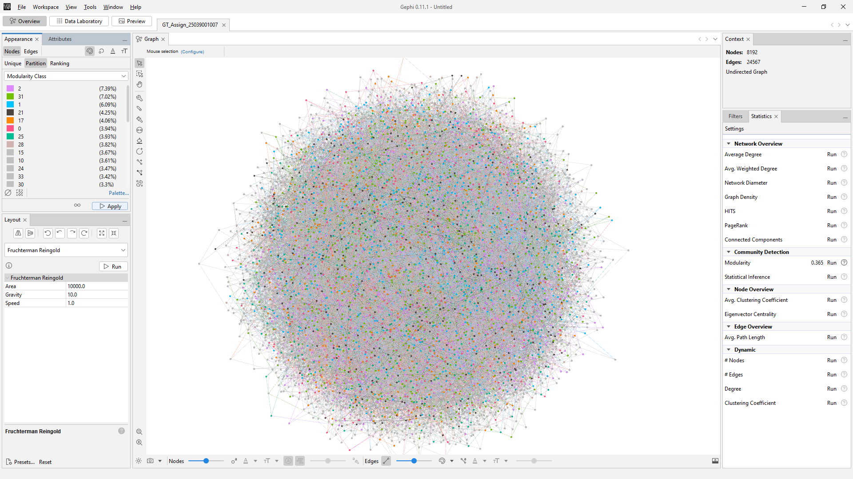
Figure: Nodes Coloured by Community (Modularity Class) and Sized by Degree

3.6 Gephi Statistics Results
The following five network statistics were computed directly within Gephi [8]:

3.6a Average Degree
Average degree ≈ 6.0, consistent with the BA model [1] parameter m = 3 (expected 2m = 6). The degree distribution histogram confirms power-law behaviour.
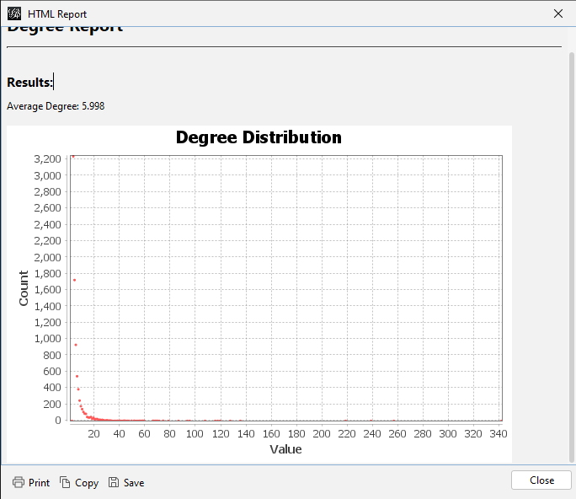
Figure: 3.6a Average Degree

3.6b Network Diameter
Diameter = 7, computed via BFS from all nodes. Confirms the small-world property: information can reach any node in the network within just 7 hops.
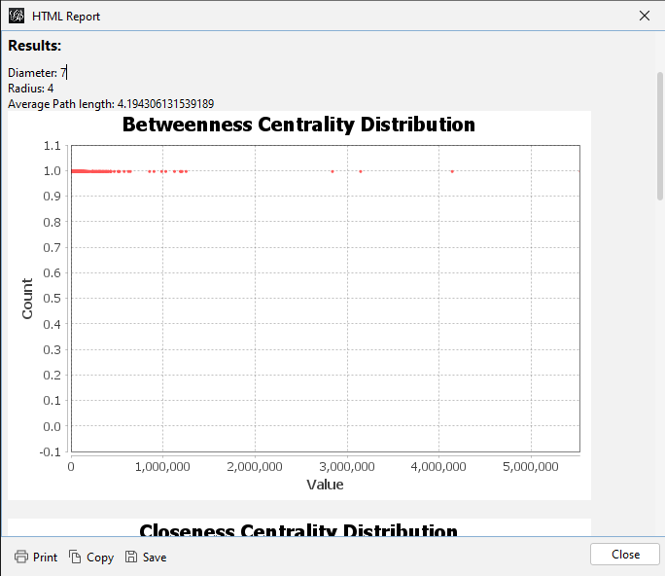
Figure: 3.6b Network Diameter

3.6c Graph Density
Density ≈ 0.000732 (0.073%), confirming the network is very sparse. This is typical of large scale-free networks generated by preferential attachment [1].
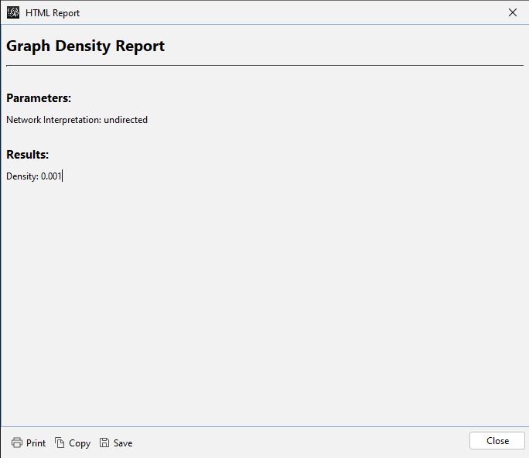
Figure: 3.6c Graph Density

3.6d PageRank
PageRank scores identify the most important nodes beyond just degree. High-PageRank nodes are connected to other high-degree nodes, making them critical hubs for information flow through the network.
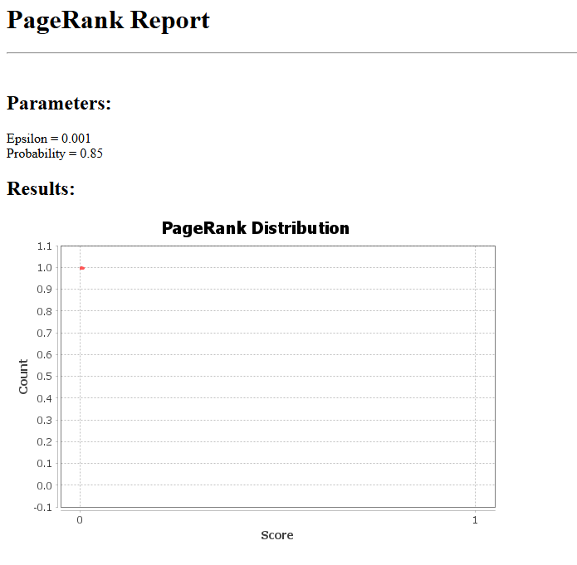
Figure: 3.6d PageRank

3.6e HITS Algorithm
HITS (Hyperlink-Induced Topic Search) identifies hubs (nodes with many links to authorities) and authorities (nodes pointed to by many hubs). In this undirected graph, hub and authority scores are strongly correlated with degree.
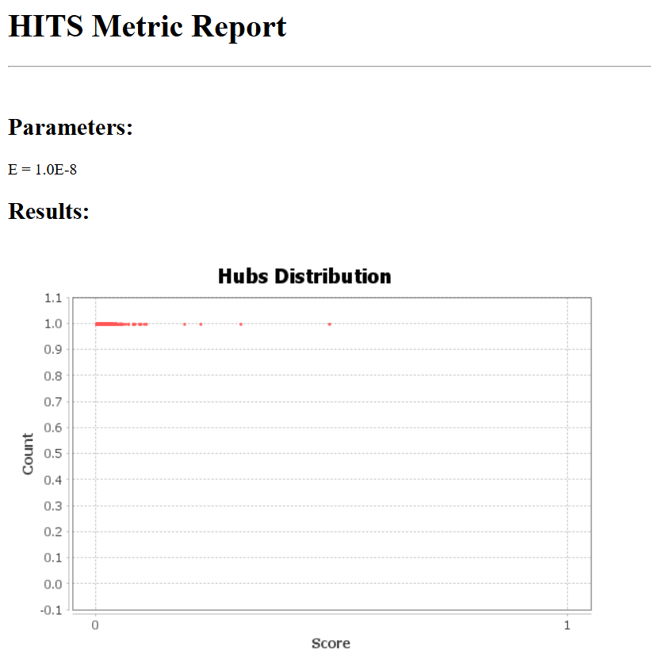
Figure: 3.6e HITS Algorithm

3.7 Top-Degree Subgraph
A degree-range filter was applied in Gephi [8] to display only the top 20% of nodes by degree (approximately degree ≥ 10). This reveals the network's core: the interconnected hub nodes that maintain global connectivity. Removing these hub nodes would fragment the network into many disconnected components — a characteristic vulnerability of scale-free networks to targeted attacks [1].
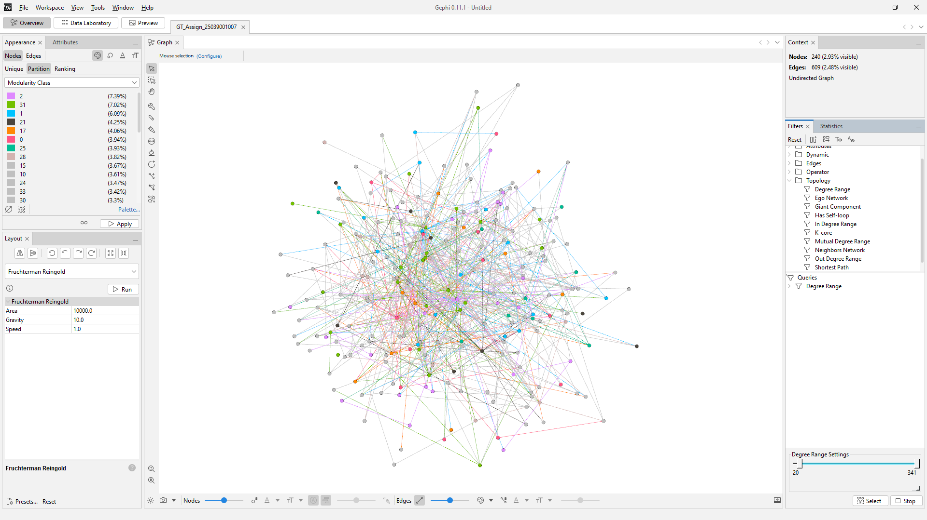
Figure: Top-Degree Nodes Subgraph (Top 20% by Degree, Gephi)

Analysis and Interpretation

Real-World Network Properties
The generated network successfully replicates real-world complex network properties [1]. The power-law degree distribution (visible in both the log-log degree histogram and Gephi's degree distribution panel) matches social networks, citation networks, and internet topology. The small diameter of 7 relative to network size of 8,192 nodes demonstrates the small-world effect, where information propagates rapidly.

Community Structure
The Louvain algorithm [2] detected 24 distinct communities with modularity Q = 0.386. This indicates meaningful community structure — the network is not random but organised into functional groups that are denser internally than externally. Community boundaries are bridged by a small number of high-betweenness nodes.

Centrality and Hub Importance
Hub nodes (high degree) are critical for network function: they have high closeness centrality (can quickly reach any node), high betweenness (lie on many shortest paths), and high PageRank (connected to other important nodes). Removing hub nodes would dramatically increase diameter and fragment communities.

Resilience Properties
Scale-free networks [1] exhibit robust-yet-fragile behaviour: resilient to random node failures (most removed nodes will be low-degree peripheral nodes) but highly vulnerable to targeted attacks on hub nodes. This has practical implications for designing resilient infrastructure networks.

NetworkX vs. Gephi Consistency
Metrics computed independently in NetworkX [3] (Python) and Gephi [8] (Java) are consistent, validating both implementations. Gephi provides superior interactive visualisation capabilities while NetworkX enables programmatic analysis and automation.

Challenges and Limitations

Computational Complexity
Several algorithms (network diameter, betweenness centrality, Kamada-Kawai layout) have O(n²) or O(n³) complexity. For 8,192 nodes these were feasible but required several minutes. For truly large networks (millions of nodes), approximate algorithms would be necessary.

Visualisation Scalability
8,192 nodes with 24,567 edges produces overlapping edges that obscure structure. Techniques used to mitigate this included: low edge opacity, node colouring, sampling (Kamada-Kawai), and subgraph filtering (top-degree nodes view in Gephi [8]).

Model Limitations
The Barabási-Albert model [1] generates scale-free networks but does not capture all real-world properties such as geographic constraints, temporal dynamics, or weighted edges. More sophisticated models (LFR benchmark, stochastic block models) could add these dimensions.

Modularity Resolution Limit
The Louvain algorithm [2] is subject to the resolution limit: it may merge small communities or split large ones depending on graph size. The 24 communities detected represent an approximation of the true community structure.

Conclusion
This assignment successfully demonstrated the complete workflow of synthetic network generation, analysis, and visualisation. The Barabási-Albert model [1] with n = 8,192 nodes and m = 3 produced a graph with verified scale-free and small-world properties. NetworkX [3] provided programmatic analysis of 11 network metrics and 6 visualisation layouts, while Gephi [8] enabled interactive exploration with 3 additional layout algorithms, community colouring, degree-based sizing, and 5 statistical analyses.
The key finding is that preferential attachment [1] alone is sufficient to produce the complex structural properties observed in real-world networks: power-law degree distribution, small diameter, and strong community structure. These properties make scale-free networks both powerful (efficient information routing) and fragile (vulnerable to targeted hub removal).
- Synthetic network generation with realistic scale-free properties [1]
- Five NetworkX [3] layout visualisations revealing different structural aspects
- Eleven quantitative network metrics computed and interpreted
- Louvain [2] community detection identifying 24 functional groups (Q = 0.386)
- Three Gephi [8] layout algorithms with interactive visual analysis
- Five Gephi statistics independently confirming NetworkX results

References
1. Barabási, A. L., & Albert, R. (1999). Emergence of scaling in random networks. Science, 286(5439), 509–512.
2. Blondel, V. D., Guillaume, J. L., Lambiotte, R., & Lefebvre, E. (2008). Fast unfolding of communities in large networks. Journal of Statistical Mechanics, P10008.
3. Hagberg, A., Swart, P., & Schult, D. (2008). Exploring network structure, dynamics, and function using NetworkX. Proceedings of the 7th Python in Science Conference.
4. Jacomy, M., Venturini, T., Heymann, S., & Bastian, M. (2014). ForceAtlas2, a continuous graph layout algorithm for handy network visualisation. PLoS ONE, 9(6).
5. Fruchterman, T. M., & Reingold, E. M. (1991). Graph drawing by force-directed placement. Software: Practice and Experience, 21(11), 1129–1164.
6. Yifan Hu. (2005). Efficient and high quality force-directed graph drawing. The Mathematica Journal, 10(1).
7. NetworkX Documentation (v3.6). https://networkx.org/documentation/stable/
8. Gephi: The Open Graph Viz Platform. https://gephi.org/

Appendix: Generated Files

File | Description
GT_Assign_25039001007.ipynb | Jupyter notebook with all Python code and analysis
GT_Assign_25039001007.gexf | Network file for Gephi (8,192 nodes, 24,567 edges)
GT_Assign_25039001007.gephi | Gephi project file with layouts and statistics
network_metrics_summary.csv | All 11 network metrics in CSV format
01_spring_layout.png | Spring layout (NetworkX)
02_circular_layout.png | Circular layout (NetworkX)
03_kamada_kawai_layout.png | Kamada-Kawai layout, 2K sample (NetworkX)
04_shell_layout.png | Shell layout (NetworkX)
05_spectral_layout.png | Spectral layout (NetworkX)
06_communities_louvain.png | Community detection (NetworkX / Louvain)
07_degree_distribution.png | Degree distribution histograms (NetworkX)
08_clustering_analysis.png | Clustering coefficient analysis (NetworkX)
01_gephi_forceatlas2.png | ForceAtlas2 layout screenshot (Gephi)
02_gephi_fruchterman.png | Fruchterman-Reingold layout screenshot (Gephi)
03_gephi_yifan_hu.png | Yifan Hu layout screenshot (Gephi)
04_gephi_colored_sized.png | Coloured by community, sized by degree (Gephi)
05_statistics_avg_degree.png | Average degree statistics (Gephi)
06_statistics_diameter.png | Network diameter statistics (Gephi)
07_statistics_density.png | Graph density statistics (Gephi)
08_statistics_pagerank.png | PageRank statistics (Gephi)
09_statistics_hits.png | HITS algorithm statistics (Gephi)
10_gephi_top_nodes.png | Top-degree subgraph visualisation (Gephi)

